**NIMBUS: CLOSE RANGE INFORMATION SHARING FOR LOCAL COOPERATION**

Once upon a time, people interacted in high fidelity face-to-face. That multi-channeled pipe carrying pheromones to phonemes has become a trickle of bits. Those days are gone and are probably not coming back soon. No one is going to give up their devices and connection to the ether. But we can ameliorate by changing the bandwidth between people, expanding or filtering the pipe. Nimbus aims to address this. Users exude a “nimbus” of information that is visible in their geographical surroundings. A multiplicity of data may be revealed, enabling a plethora of possible cooperative activities. For example, a group of people convening at a social event could become familiarized with each other by perusing each other’s profiles. Alternatively, a business could scan in-store patron profiles to make customized offers. Participant information could be authenticated by trusted parties to foster trust. Without knowledge of individuals, people often stereotype based on generalizations, sometimes to tragic outcomes. Sharing authentic information published by individuals can help avoid stereotyping.

More use cases:

1. A customer enters a store. The storekeeper is informed what the customer is looking for and if the customer is trustworthy (no criminal record, etc.).

2. A man attends a social gathering and informs women in the vicinity of some personal information, including being a safe person to talk to and/or leave with.

3. A police car passes a car and the driver's nimbus vouches for their good driving record.

4. Shy people let their AIs commune a bit before proceeding on a more personal basis.

The basic operation of Nimbus is shown below:

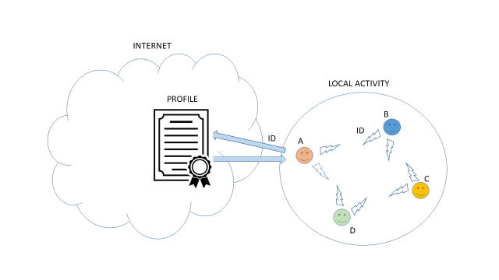

Participants of a local activity of some sort are shown as they broadcast identifying information to each other. The identity information is being used as a key to retrieve profile information from the internet. This information could be constrained to being relevant to the activity, or participants could filter it from the profile. Messaging information could also be exchanged via profiles to allow further direct communication.

A prototype of Nimbus as an Android app can be installed from http://dialectek.com/Nimbus/Nimbus.apk. The prototype uses Bluetooth Low Energy (BLE) as a means of close range communication. See <https://litum.com/what-is-ble-how-does-ble-work/> for more information. The app also contains geolocation capabilities to aid in locating participants in space. The interface is shown below:

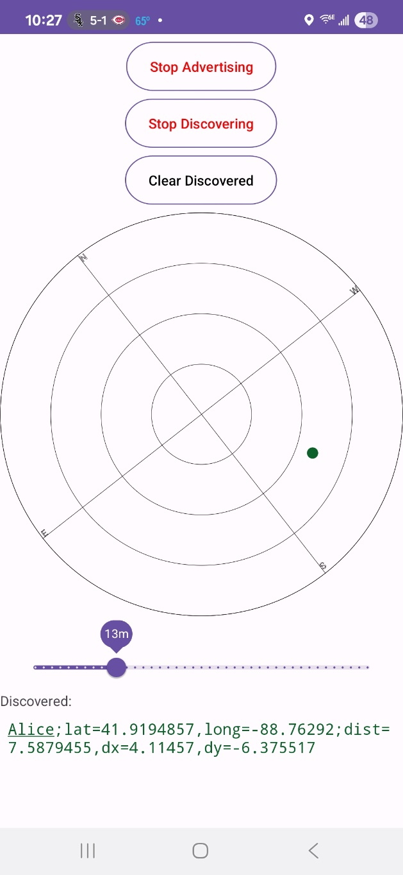

Contact: Tom Portegys, portegys@gmail.com